A Guide to know Spotify API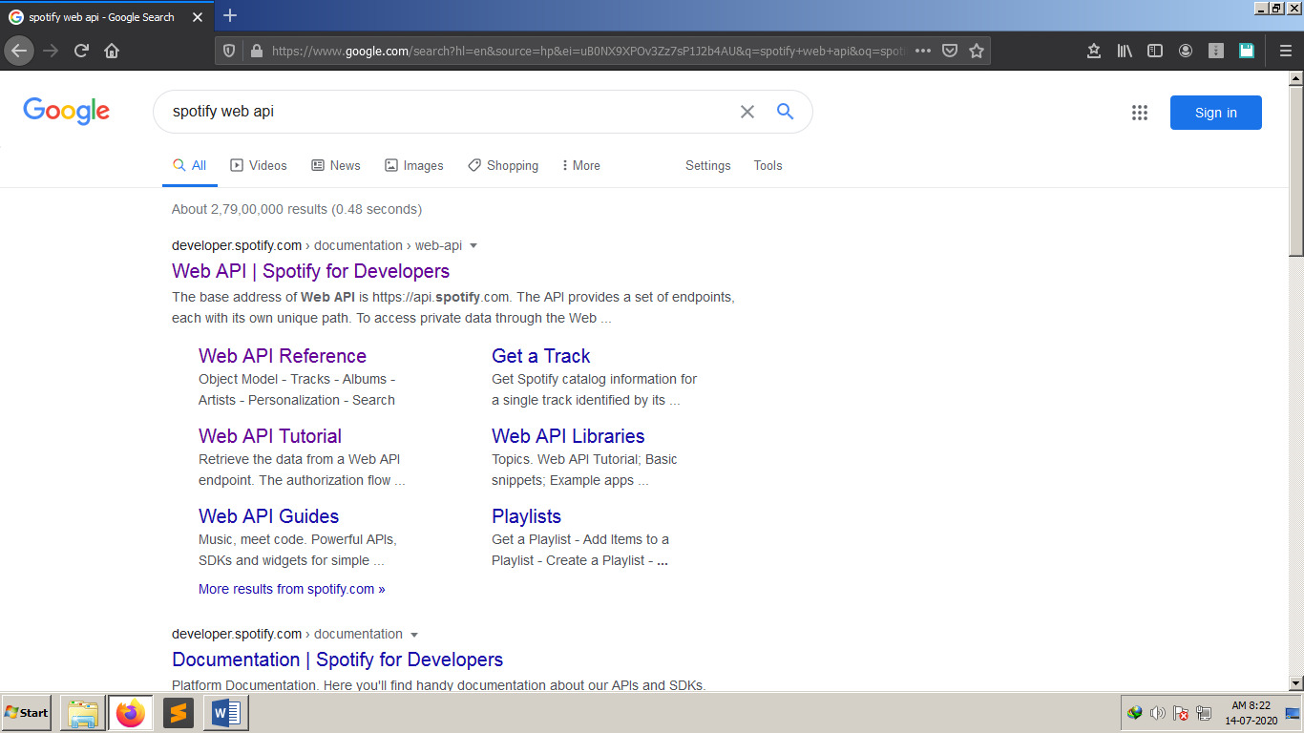

After going to Dashboard and login (I logged in with my facebook account and had setup this client ID and Client Secret Key. Anyone can use this key without logging in, if I share the key with them)

You will see how it is used in the python Script.(Music.py)

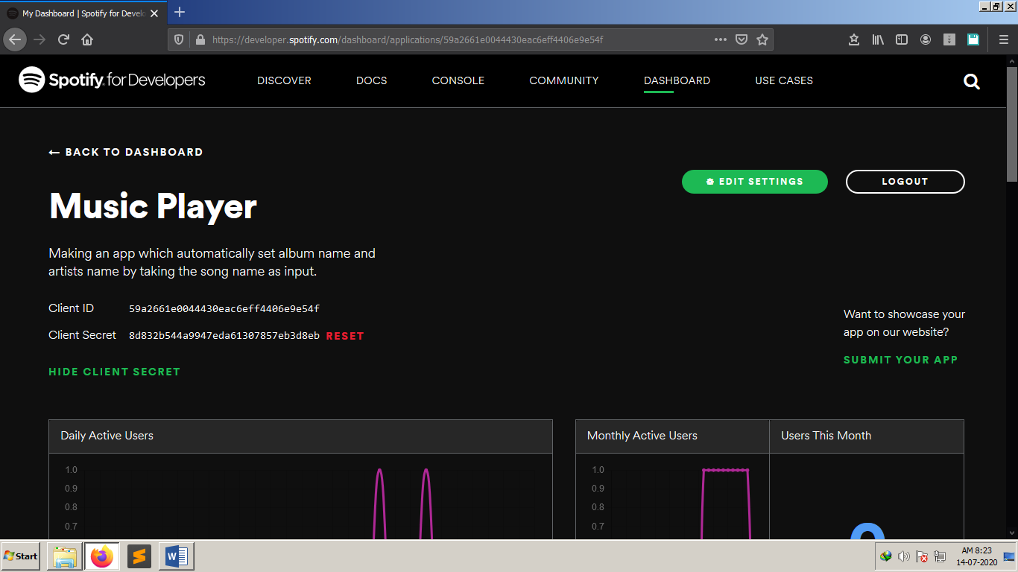

Going to the console tab You will see many API end points (in the left bar of photo) like albums,artists,browse etc.

We will use search API Endpoint.

To use this u need to login with any account (facebook is best, its quick).

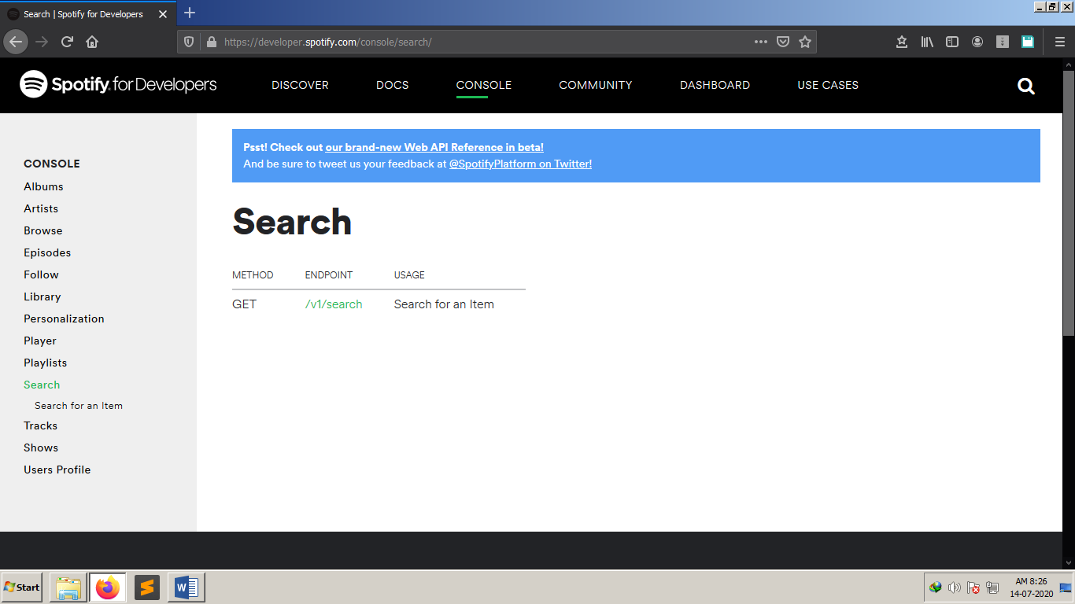

This is an example of the search API. You Enter a information and generate a token and u get the result in json.

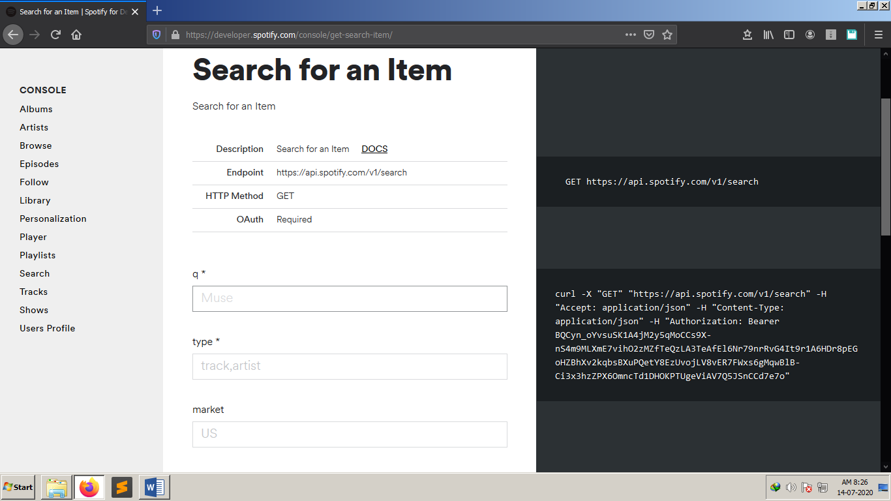

this image is the same page as In above image (after I clicked fill sample data and try it )

U can see the result on right side. Dont try to read it from here when u try it.Its confusing.

I copied it in output.json

Now u can read it by opening in notepad++ or your browser.

